Key assumptions and dependencies

* The target market will have access to online banking, credit cards or debit cards.
* Acess to internet and smart devices to access ecommerce sites and applications.
* Courier and delivery services will guarantee safe deliveries.
* Returns will be minimised through good put togwther products.
* Webservices and applications will be steady to insure that theres no interruptions which will cause loss of potential sales.
* The system will be coss effective overall during development, implementation, maintenance etc.
* Safe and secure database and payment methods is necessity.
* Fast and problem free online service delivery.
* There will always be supplier of goods to ensure products at all times and enough supply to fill the demand.

# Appendix

## Calculations

Total sales = clothing + other

Subtotal Direct Cost of Sales = clothing + other

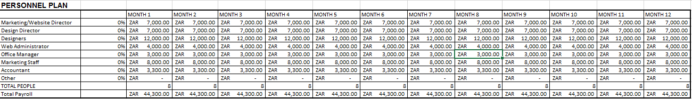

## Calculations

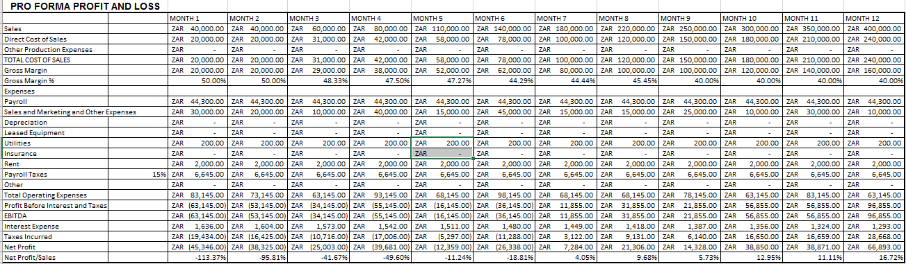Total Payroll = Marketing/Website Director + Design Director + Designers + Web Administrator + Office Manager + Marketing Staff + Account + Other



## 

## Calculations

Subtotal Cash Received = Cash Received + Additional Cash Received

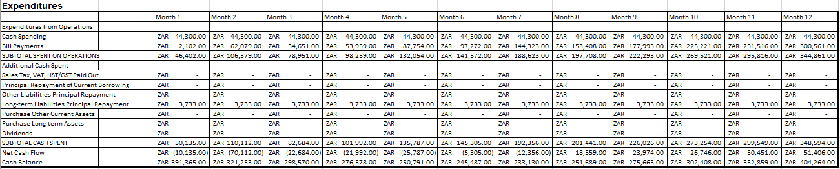

## Calculations

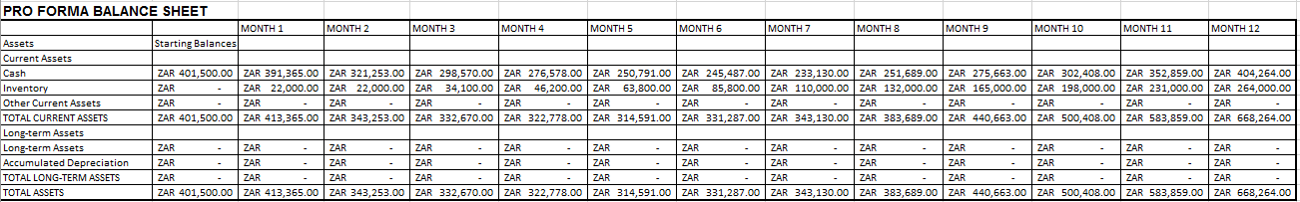

## Calculations

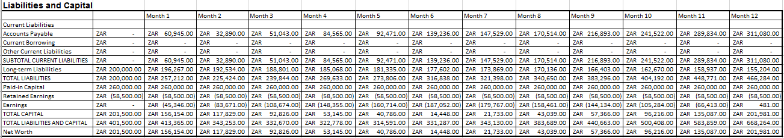

## Calculations